**EXPERIMENT NO**

Design a dice that displays a a. Red background when 6 comes up b. Green background when 4 comes up c. Blue background when 2 comes up

**CIRCUIT DIAGRAM**

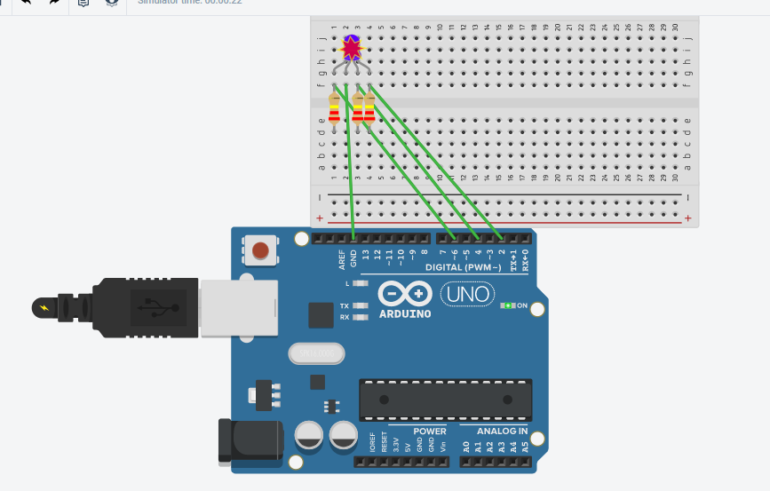

Theory

In this the concept is used about the RGB led. **They work on the basic concept of combination of the basic colors of any shade, that is, red, green and blue.** These LEDs have three tiny LEDs of 3 primary colors (red, green and blue) where a terminal is common for all. Some have common positive terminal (anode) and some have common negative terminal (cathode). When different voltage is applied to different LEDs, they make a mixture and produce several thousands of colors. The one that we are going to use is the common cathode RGB led. So, we will connect the common pin to the GND of Arduino and the other three leads of the led’s to the PWM pins of Arduino.

**LEARNING & OBSEVATION**

In this we can run about the RGB led. In this we can’t distinguish the common anode and common cathode type. In this we can connect to distinguish whether the common cathode or the anode type.In is this when we connect the led with high resistance then the led will blast.In this we learn to connect the led with the register and run with the help of the arduino.

**PROBLEMS AND TROUBLESHOOTING**

In this we face the problem to connect the led with the aurdino.

Selection of the the register.

Connect the wire toarduino.

Choosing the proper led.

Connection problem.

**PRECAUTION**

We must connect the wire propely otherwise the led will not glow.

We must use the led properly so that the le can’t broke.

Use the wire properly.

Use the arduino correctly.

**Learning outcomes**

We can learn about the the RGB led .We can learn about to make the dice with the help of the arduino and the RGB led.